**P4. Arreglos y funciones**

**Benjamín Valdez Rodríguez**

**A00822027**

**Código**

//

// main.c

// P4 Arreglos y funciones

//

// Created by Benjamin Valdez on 2/21/20.

//

#include "stdio.h"

**void** printMatrix(**int** matrix[2][2]) {

**for**(**int** i = 0; i < 2; i++) {

**for**(**int** j = 0; j < 2; j++) {

printf("%d ", matrix[i][j]);

}

printf("\n");

}

}

**void** addMatrices(**int** firstMatrix[2][2], **int** secondMatrix[2][2]) {

**int** additionMatrix[2][2];

**for**(**int** i = 0; i < 2; i++) {

**for**(**int** j = 0; j < 2; j++) {

additionMatrix[i][j] = firstMatrix[i][j] + secondMatrix[i][j];

}

}

printf("Addition\n");

printMatrix(additionMatrix);

}

**void** substractMatrices(**int** firstMatrix[2][2], **int** secondMatrix[2][2]) {

**int** subtractionMatrix[2][2];

**for**(**int** i = 0; i < 2; i++) {

**for**(**int** j = 0; j < 2; j++) {

subtractionMatrix[i][j] = firstMatrix[i][j] - secondMatrix[i][j];

}

}

printf("Subtraction\n");

printMatrix(subtractionMatrix);

}

**void** multiplyMatrices(**int** firstMatrix[2][2], **int** secondMatrix[2][2]) {

**int** number = 0;

**int** multiplicationMatrix[2][2];

**for**(**int** i = 0; i < 2; i++) {

**for**(**int** j = 0; j < 2; j++) {

**for**(**int** k = 0; k < 2; k++) {

number += firstMatrix[i][k] * secondMatrix[k][j];

}

multiplicationMatrix[i][j] = number;

number = 0;

}

}

printf("Multiplication\n");

printMatrix(multiplicationMatrix);

}

**void** readMatrix(**int** Matrix[2][2]) {

**for**(**int** i = 0; i < 2; i++) {

**for**(**int** j = 0; j < 2; j++) {

scanf("%d", &Matrix[i][j]);

}

}

}

**int** main(**int** argc, **const** **char** * argv[]) {

**int** firstMatrix[2][2];

**int** secondMatrix[2][2];

printf("Enter the first Matrix: \n");

readMatrix(firstMatrix);

printf("Enter the second matrix: \n");

readMatrix(secondMatrix);

printf("First Matrix: \n");

printMatrix(firstMatrix);

printf("Second Matrix: \n");

printMatrix(secondMatrix);

addMatrices(firstMatrix, secondMatrix);

substractMatrices(firstMatrix, secondMatrix);

multiplyMatrices(firstMatrix, secondMatrix);

**return** 0;

}

**Caso de Prueba 1**

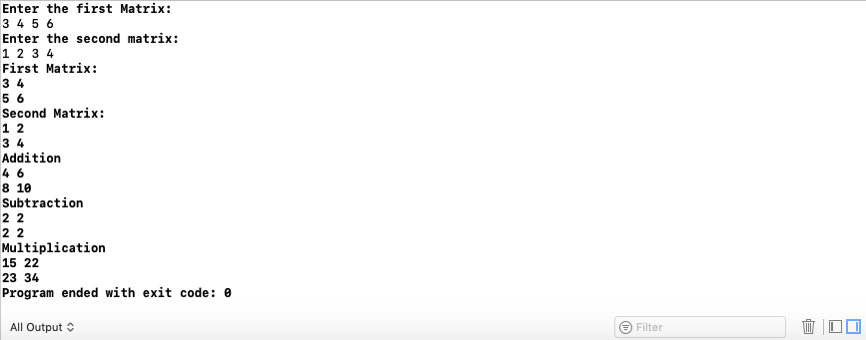

**Caso de Prueba 2**

